# Creating Android Virtual Device

This is a simple guide on how to create an Android Virtual Device. This guide is for **Android Studio 2022.2.1 Patch 2.** If you are working from a personal computer, you will need to download and install the highlighted version.

**1: Setting up Android Studio**

* + - From the Start Menu, open **Android Studio**.
    - When Android Studio first opens up, there may be a number of updates that it must run through.
      * + Run through these updates.
        + Run through basic setup if needed.
        + If there are any errors, click on the possible solutions (this should be fine)

**2: Setting up an Android Emulator**

* + - Once all the updates and errors have been fixed, click on **More Actions > Virtual Device Manager**

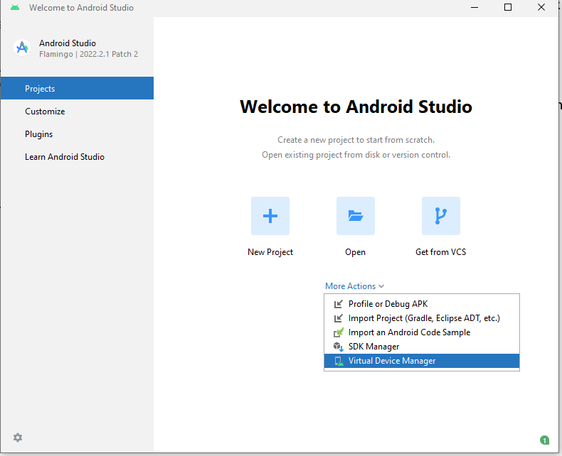

* + - Click on “**Create Virtual Device**”.

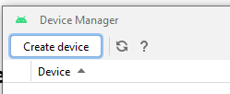

* + - Click on **Pixel 4,** then click **‘Next’** on the bottom right.

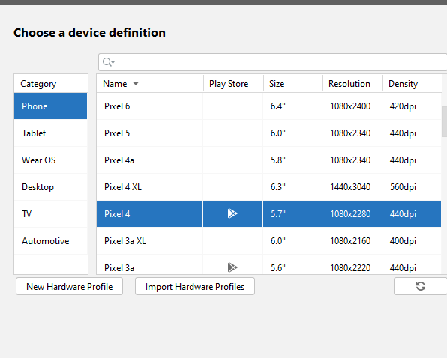



* + - Click on **S API 31, you may need to download**. If so, click **download icon**  first, then click on **S (the one you downloaded)**, then click **Next**.

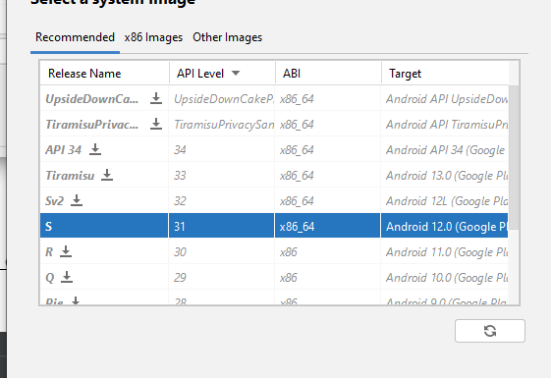

* + - On the next page, make sure that the AVD Name is **Pixel 4 API 31.**
* Click on **‘Finish’**. To run the emulator by clicking on the **Play** symbol. You can now close **Android Studio.**
  + You have to open **Android Studio** every time you need the emulator.

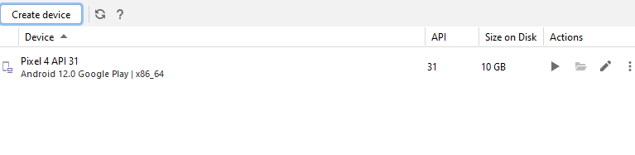

* With your emulator running, simply drag your **.apk** to install
* 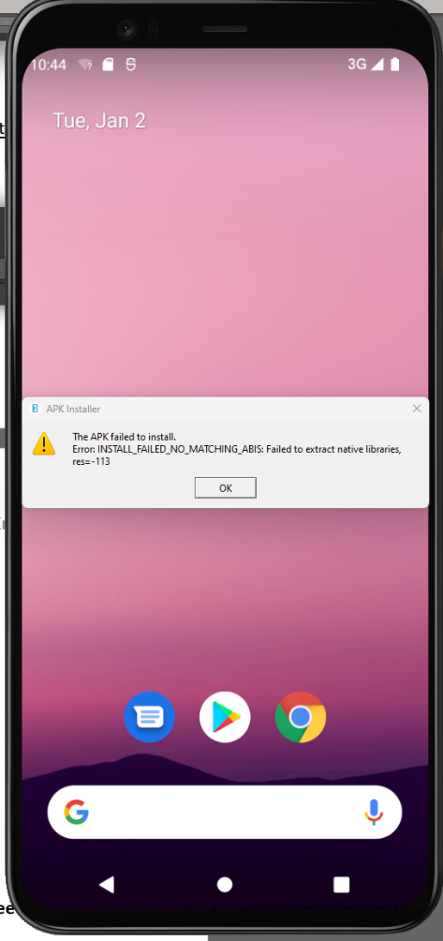You may get the following error when trying to install (drag) a **Unity built .apk** to the emulator.
* Since the emulator is running X86_64 architecture, we need to add this to our build.
* Go to your Unity android project and do the following.
* Go to **Edit** > **Project** **Settings** > **Player** and open the **Other Settings** tab.
* 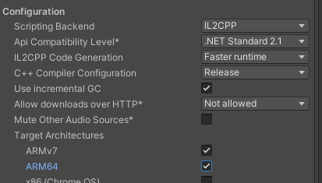Change **Configuration** > **Scripting Backend** from “Mono” to “IL2CPP”. Then check the “ARM64” option and build again (it’ll take longer).